# Android Volley

Recitation COM S 309

Introduction

* Android volley is a networking library to make networking calls much easier and is developed by Google
* Download a Volley example project from: <https://git.linux.iastate.edu/cs309/Fall2018/ExampleProjects>

OR

<https://git.linux.iastate.edu/cs309/tutorials_android>

First, you can download and import this project in Android Studio and then go through the slides. Then create your own app using Volley and run.

* + **READ THE THINGS TO REMEMBER SECTION AT THE END!!!**

Get Started

* We will create a sample app that sends the following requests to web API and show responses on Android activity.

1. String request
2. JSON request (JSON object and JSON array)
   * JSON is a text format to exchange data
3. Image request

* The basic tasks to do that are:

1. Create activities
2. Import Volley library
3. Make requests

Task 1: Create Activities

1. Create a new project.
2. Create UI with 3 buttons.

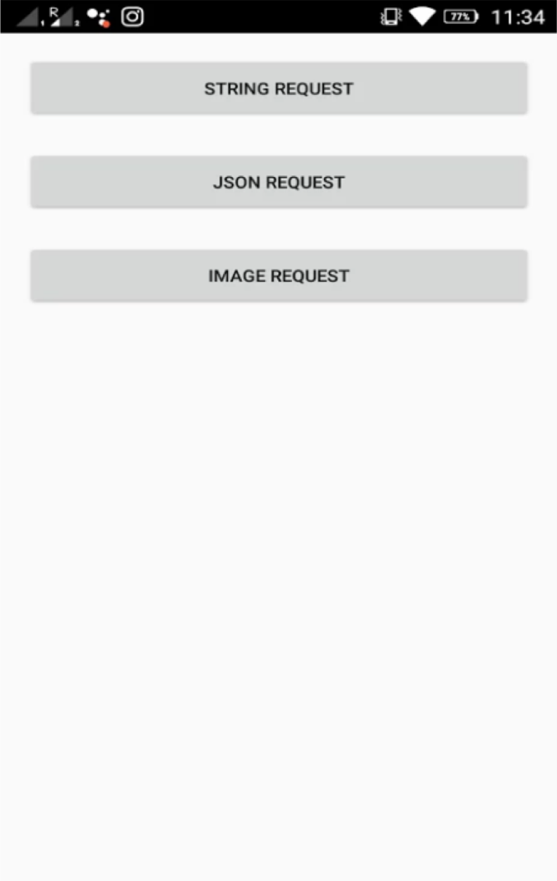

<**LinearLayout xmlns:android=**[**"h**](http://schemas.android.com/apk/res/android)**t**[**tp://schemas.android.com/apk/res/android"**](http://schemas.android.com/apk/res/android)

**xmlns:tools=**[**"h**](http://schemas.android.com/tools)**t**[**tp://schemas.android.com/tools**](http://schemas.android.com/tools)**" android:layout_width="match_parent" android:layout_height="match_parent" android:orientation="vertical" android:paddingBottom="16dp" android:paddingLeft="16dp" android:paddingRight="1dp" android:paddingTop="16dp" tools:context=".MainActivity"** >

<**Button android:id="@+id/btnStringRequest" android:layout_width="fill_parent" android:layout_height="wrap_content" android:layout_marginBottom="20dp" android:text="String Request"** />

<**Button android:id="@+id/btnJsonRequest" android:layout_width="fill_parent" android:layout_height="wrap_content" android:layout_marginBottom="20dp" android:text="JSON Request"** />

<**Button android:id="@+id/btnImageRequest" android:layout_width="fill_parent" android:layout_height="wrap_content" android:layout_marginBottom="20dp" android:text="Image Request"** />

</**LinearLayout**>

XML Layout for this activity

1. Create three more activities and link them to their respective buttons.

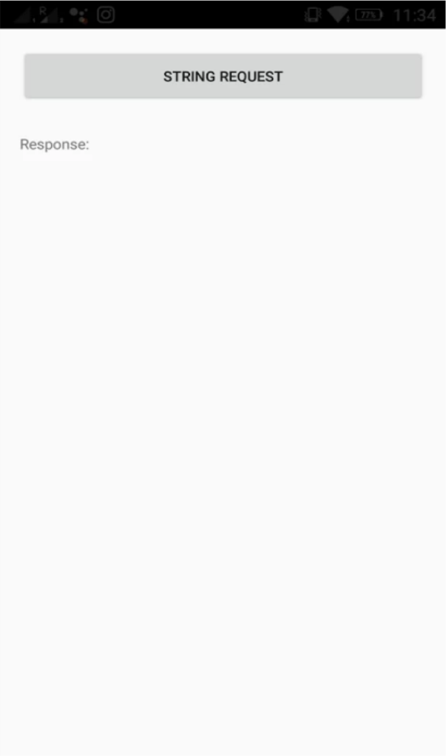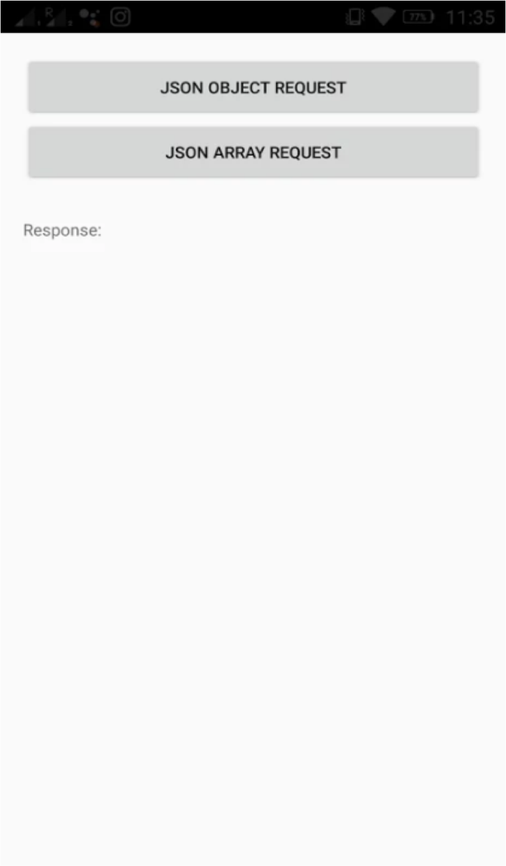

Task 2: Import Volley Library

Three steps:

* 1. Add dependencies
  2. Add controller classes
  3. Add permission

STEP 1. Add Dependencies

* 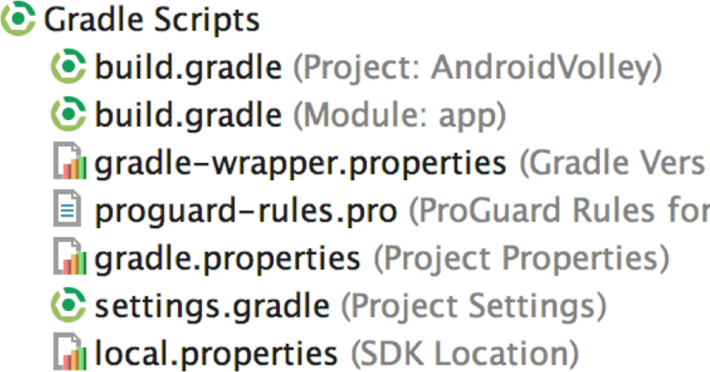Open build.gradle and add the volley dependency.
* Add this line under dependencies:
  + implementation **'com.android.volley:volley:1.1.1'**

dependencies {

compile fileTree(**dir**: **'libs'**, **include**: [**'*.jar'**]) androidTestCompile(**'com.android.support.test.espresso:espresso-core:2.2.2'**, {

exclude **group**: **'com.android.support'**, **module**: **'support-annotations'**

})

implementation **'com.android.support:appcompat-v7:26.+'**

implementation **'com.android.support.constraint:constraint-layout:1.0.2'**

implementation **'com.android.support:design:26.+'**

testImplementation **'junit:junit:4.12'**

}

implementation **'com.android.volley:volley:1.1.1'**

STEP 2. Add Controller Classes

##### *First, create two packages *app* and *net_utils* to keep project organized.

##### *\*This is one way to implement volley requests,*

##### *Look at things to remember section!*

Then, create these classes under the packages.

1. Appcontroller.java
2. Const.java
3. LruBitmapCache.java

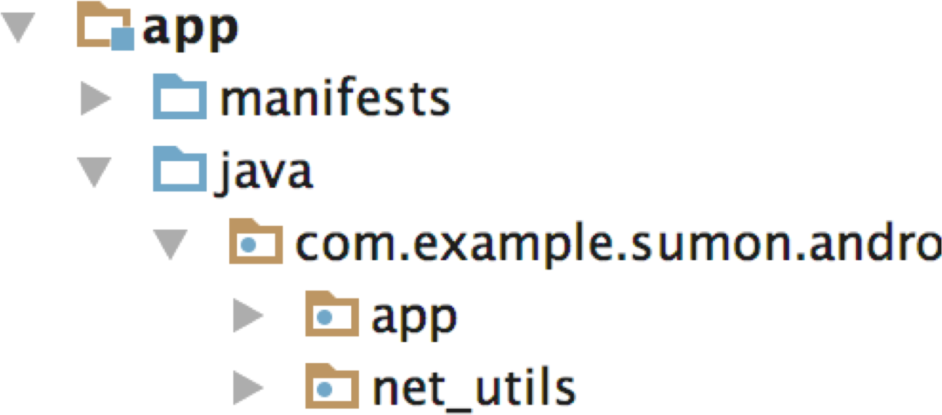

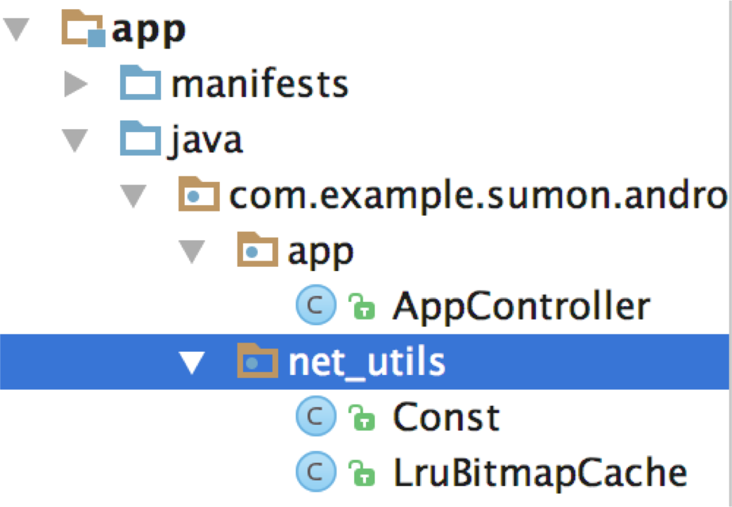

## AppController.java

* This class is used to handle all the http requests that we make from the app.

**import info.vamsikrishna.volleyeg.utils.LruBitmapCache; import android.app.Application;**

**import android.text.TextUtils;**

**import com.android.volley.Request; import com.android.volley.RequestQueue;**

**import com.android.volley.toolbox.ImageLoader; import com.android.volley.toolbox.Volley;**

**public class AppController extends Application { public static final String *TAG* = AppController.class**

**.getSimpleName();**

**private RequestQueue mRequestQueue; private ImageLoader mImageLoader;**

**private static AppController *mInstance*; @Override**

**public void onCreate() {**

**super.onCreate();**

***mInstance* = this;**

**}**

**public static synchronized AppController getInstance() { return *mInstance*;**

* You don’t have to change anything in the class.

**}**

**public RequestQueue getRequestQueue() { if (mRequestQueue == null) {**

**mRequestQueue = Volley.*newRequestQueue*(getApplicationContext());**

**}**

**return mRequestQueue;**

**}**

**public ImageLoader getImageLoader() { getRequestQueue();**

**if (mImageLoader == null) {**

**mImageLoader = new ImageLoader(this.mRequestQueue, new LruBitmapCache());**

**}**

**return this.mImageLoader;**

**}**

**public <T> void addToRequestQueue(Request<T> req, String tag) {**

***// set the default tag if tag is empty* req.setTag(TextUtils.*isEmpty*(tag) ? *TAG* : tag); getRequestQueue().add(req);**

**}**

**public <T> void addToRequestQueue(Request<T> req) { req.setTag(*TAG*);**

**getRequestQueue().add(req);**

**}**

**public void cancelPendingRequests(Object tag) { if (mRequestQueue != null) {**

**mRequestQueue.cancelAll(tag);**

**}**

**}**

**}**

## Const.java

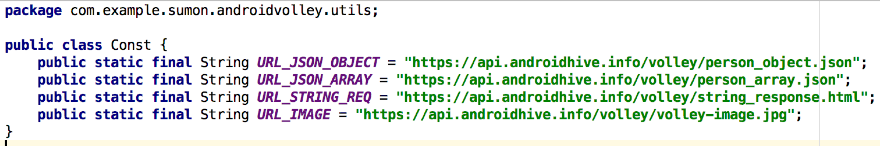

### In this class, we store the URLs for network calls. Visit the URLs to look at the data present in that URL.

**When trying to connect to localhost through your phone/emulator, you need to use** [**http://10.0.2.2**](http://10.0.2.2) **not localhost.**

### LruBitmapCache.java

This class is required to handle image cache. The images are in general stored using bitmaps.

**import com.android.volley.toolbox.ImageLoader.ImageCache; import android.graphics.Bitmap;**

**import android.support.v4.util.LruCache;**

**public class LruBitmapCache extends LruCache<String, Bitmap> implements**

**ImageCache {**

**public static int getDefaultLruCacheSize() {**

**final int maxMemory = (int) (Runtime.*getRuntime*().maxMemory()**

**/ 1024);**

**final int cacheSize = maxMemory / 8;**

**return cacheSize;**

**}**

**public LruBitmapCache() { this(*getDefaultLruCacheSize*());**

**}**

**public LruBitmapCache(int sizeInKiloBytes) { super(sizeInKiloBytes);**

**}**

**@Override**

**protected int sizeOf(String key, Bitmap value) {**

**return value.getRowBytes() * value.getHeight() / 1024;**

**}**

**@Override**

**public Bitmap getBitmap(String url) { return get(url);**

**}**

**@Override**

**public void putBitmap(String url, Bitmap bitmap) { put(url, bitmap);**

**}**

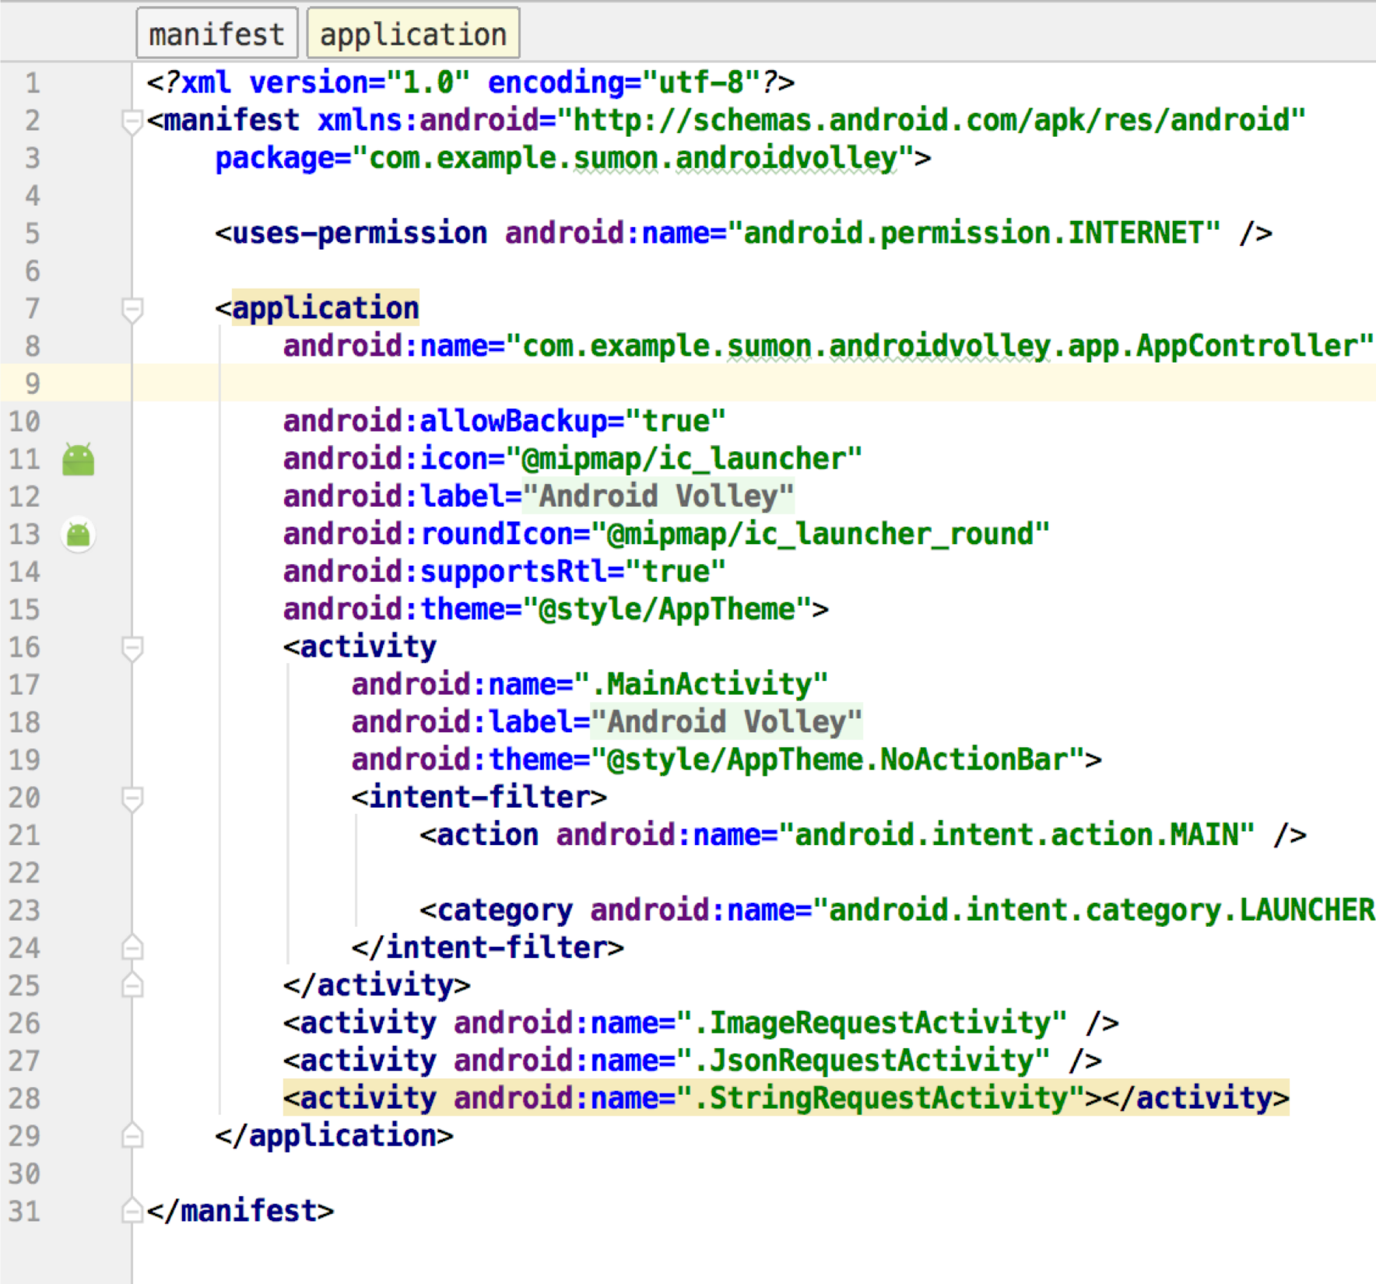

## STEP 3. Add Permission

in AndroidManifest.xml

* Open AndroidManifest.xml and add this line in <application> tag using android:name property to execute the class automatically whenever app launches.
* Also add INTERNET permission as we are going to make network calls.
* **Also add** **android:usesCleartextTraffic=”true” to the application tag**
* **These two tags are required for volley to work!!!**

Task 3: Send Request to Server

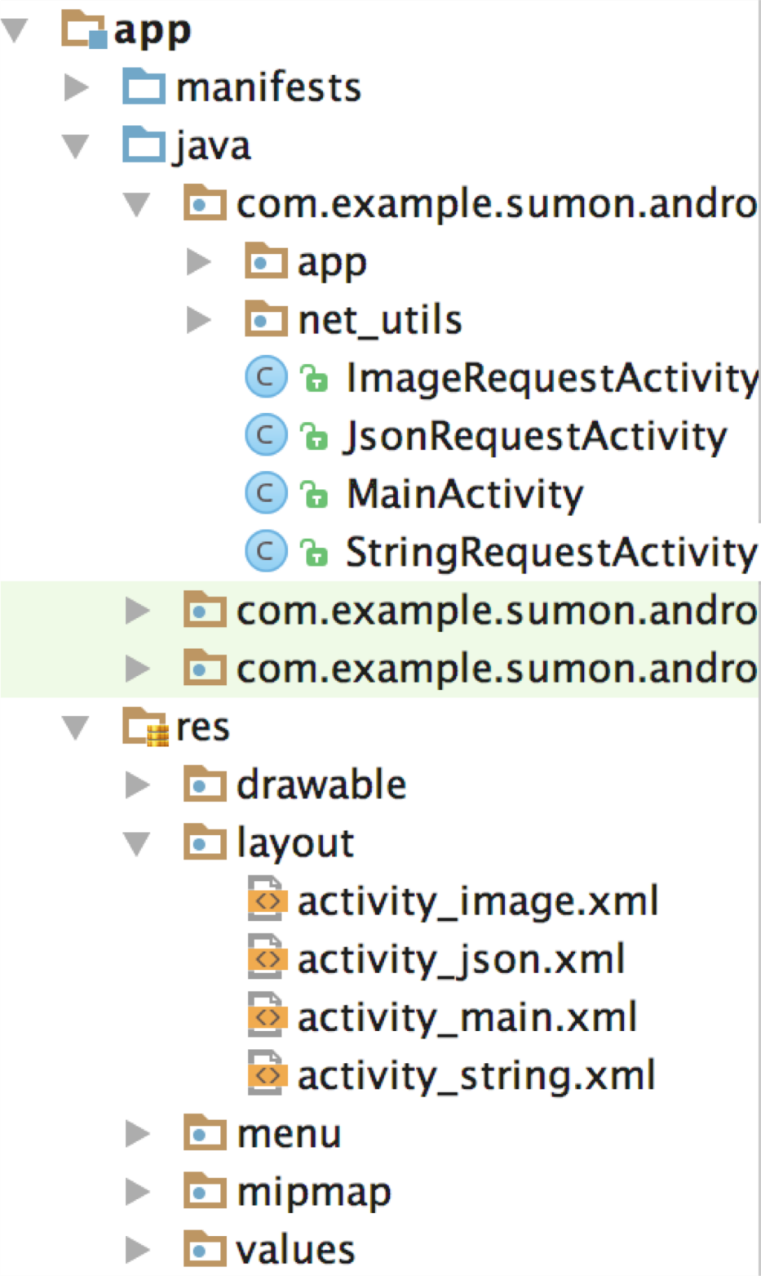

Create Three Classes

Create three classes for three different requests. These classes are linked to the respective views we already created.

Step 1. String Request Step 2. JSON Request Step 3. Image Request

*The color corresponds to the same activity

**Step 1. String request: StringRequestActivity.java**

* StringRequest class from Volley library will be used to fetch any kind of string data.
* Manipulate your response [response.tostring()] here.
* Adding request to the queue

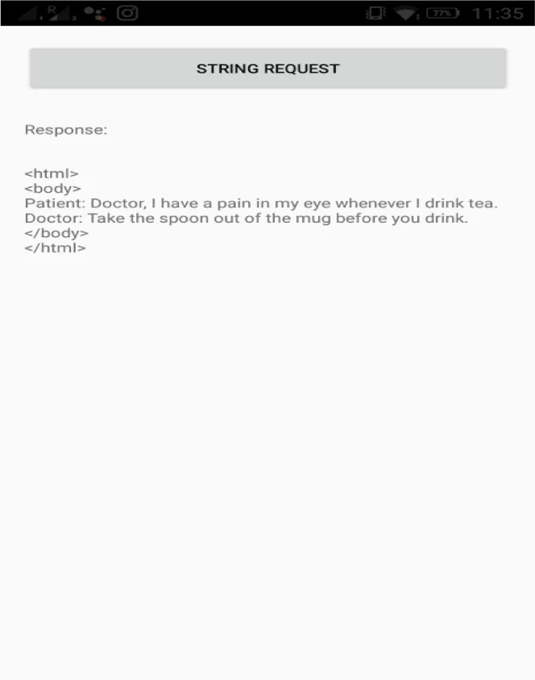

// Tag used to cancel the request String tag_string_req ="string_req";

String url ="https://api.androidhive.info/volley/string_response.html";

ProgressDialog pDialog =newProgressDialog(this); pDialog.setMessage("Loading..."); pDialog.show();

StringRequest strReq =newStringRequest(Method.GET,

url,newResponse.Listener<String>() {

@Override

publicvoidonResponse(String response) { Log.d(TAG, response.toString()); pDialog.hide();

}

},newResponse.ErrorListener() {

@Override publicvoidonErrorResponse(VolleyError error) {

VolleyLog.d(TAG,"Error: "+ error.getMessage()); pDialog.hide();

}

});

AppController.getInstance().addToRequestQueue(strReq, tag_string_req);

## Step 2. JSON Request

### We will do

* 1. JSON Object Request using GET Method
  2. JSON Array request
  3. JSON Object Request using POST Method

GET Method: Requests data from a specified resource

POST Method: Submits data to be processed to a specified resource

**2(a) JSON object request using GET method: JsonRequestActivity.java**

* Request creation
* json response will start with object notation ‘{‘
* Manipulate your response
* Adding request to the queue

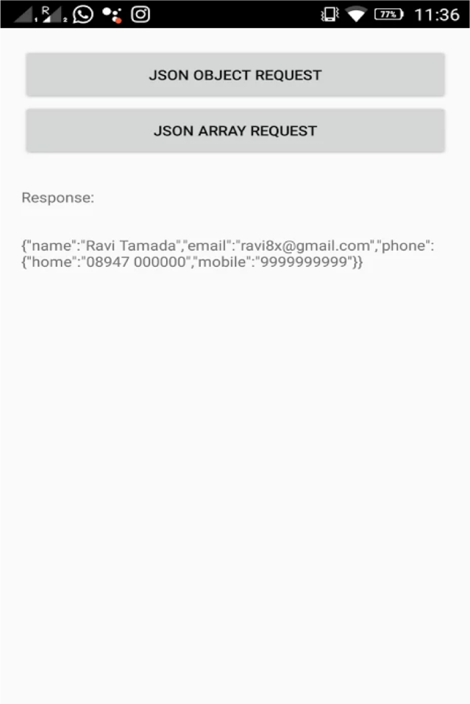

// Tag used to cancel the request String tag_json_obj ="json_obj_req";

String url ="https://api.androidhive.info/volley/person_object.json";

ProgressDialog pDialog =newProgressDialog(this); pDialog.setMessage("Loading..."); pDialog.show();

JsonObjectRequest jsonObjReq =newJsonObjectRequest(Method.GET, url,null,

newResponse.Listener<JSONObject>() {

@Override

publicvoidonResponse(JSONObject response) { Log.d(TAG, response.toString()); pDialog.hide();

}

},newResponse.ErrorListener() {

@Override publicvoidonErrorResponse(VolleyError error) {

VolleyLog.d(TAG,"Error: "+ error.getMessage());

// hide the progress dialog pDialog.hide();

}

});

AppController.getInstance().addToRequestQueue(jsonObjReq, tag_json_obj);

**2(b) JSON array request: JsonRequestActivity.java**

### Request creation

* Adding request to request queue
* You can parse this json data to get values into array

// Tag used to cancel the request String tag_json_arry ="json_array_req";

String url ="https://api.androidhive.info/volley/person_array.json";

ProgressDialog pDialog =newProgressDialog(this); pDialog.setMessage("Loading..."); pDialog.show();

JsonArrayRequest req =newJsonArrayRequest(url,

newResponse.Listener<JSONArray>() { @Override

publicvoidonResponse(JSONArray response) { Log.d(TAG, response.toString()); pDialog.hide();

}

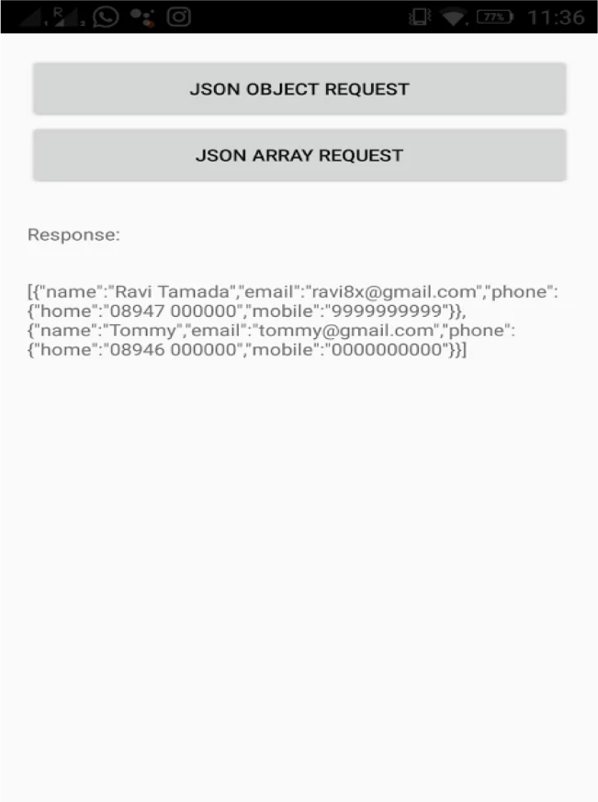

},newResponse.ErrorListener() { @Override

publicvoidonErrorResponse(VolleyError error) { VolleyLog.d(TAG,"Error: "+ error.getMessage()); pDialog.hide();

}

});

AppController.getInstance().addToRequestQueue(req, tag_json_arry);

String tag_json_obj ="json_obj_req";

String url ="https://api.androidhive.info/volley/person_object.json";

#### 2(c) JSON object request using POST method: JsonRequestActivity.java

##### This is similar but using POST Method.

* Submitting name, email and password as request parameters.
* Your web service (URL) should

be able to capture the request

ProgressDialog pDialog =newProgressDialog(this); pDialog.setMessage("Loading..."); pDialog.show();

JsonObjectRequest jsonObjReq =newJsonObjectRequest(Method.POST, url,null,

newResponse.Listener<JSONObject>() {

@Override

publicvoidonResponse(JSONObject response) { Log.d(TAG, response.toString()); pDialog.hide();

}

},newResponse.ErrorListener() {

@Override publicvoidonErrorResponse(VolleyError error) {

VolleyLog.d(TAG,"Error: "+ error.getMessage());

##### and send appropriate response.

pDialog.hide();

}

}) {

@Override

protectedMap<String, String>getParams() {

Map<String, String>params =newHashMap<String, String>(); params.put("name","Androidhive"); [params.put("email","abc@androidhive.info](mailto:abc@androidhive.info)"); params.put("password","password123");

returnparams;

}

};

AppController.getInstance().addToRequestQueue(jsonObjReq, tag_json_obj);

###### 3. Image Request

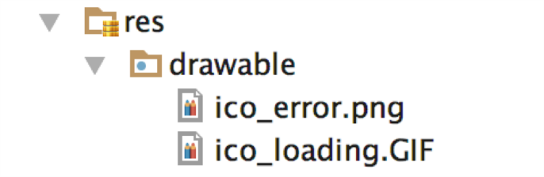

* We can use two different views in our activity to show image
  + NetworkImageView
  + ImageView
* This will load an image from an URL into NetworkImageView.
* load image into ImageView instead of NetworkImageView with success and error callbacks.
* Handle response.
* We can display default loading image or failure image.
  + Loader: The loader image will be displayed until the image gets downloaded.
  + Error: If the image fails to download, the error image will be displayed.

// Loading image with placeholder and error image imageLoader.get(Const.URL_IMAGE, ImageLoader.getImageListener(

imageView, R.drawable.ico_loading, R.drawable.ico_error));

* Place these icon images in res > drawable

ImageLoader imageLoader = AppController.getInstance().getImageLoader();

// If you are using NetworkImageView imgNetWorkView.setImageUrl(Const.URL_IMAGE, imageLoader);

ImageLoader imageLoader = AppController.getInstance().getImageLoader();

// If you are using normal ImageView imageLoader.get(Const.URL_IMAGE,newImageListener() {

@Override publicvoidonErrorResponse(VolleyError error) {

Log.e(TAG,"Image Load Error: "+ error.getMessage());

}

@Override

publicvoidonResponse(ImageContainer response,booleanarg1) { if(response.getBitmap() !=null) {

// load image into imageview imageView.setImageBitmap(response.getBitmap());

}

}

});

## Cancelling Requests

### You might want to cancel network requests. You can do it by this line

ApplicationController.getInstance().getRequestQueue().cancelAll("feed_request");

Tag that was used while adding request

* + If the tag is same for multiple requests, all the requests with that tag will be cancelled.
  + You can also use **cancellAll()** method to cancel all the requests.

ApplicationController.getInstance().getRequestQueue().cancelAll();

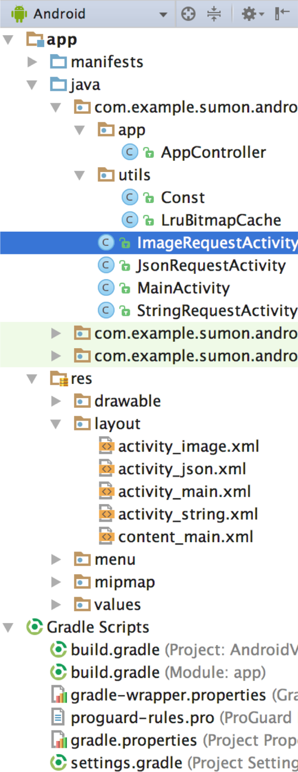

Code

* + The files we worked on:
    - Manifest
    - Activities/Java files
    - Views
    - Gradle
  + Pull code from following GIT repository.
    - https://git.linux.iastate.edu/cs309/Fall2018/ExampleProjects
  + You can learn more about Volley: [https://developer.android.com/training/volley/ind ex.html](https://developer.android.com/training/volley/ind%20ex.html)

Things to remember

* Volley runs on the **main thread** but is ***asynchronous***. This means you cannot expect volley to execute your request at a certain point in time/line of code.
  + You **can** modify UI elements within response handlers because they run on the main thread!
  + Request lifecycle:

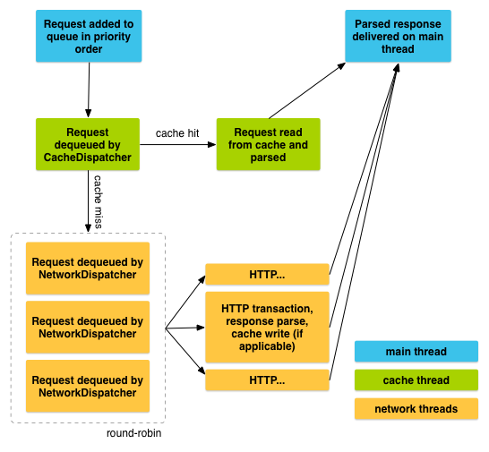

* Make sure you are using the correct version of volley!
  + If you are using volley 1.1+, the import statement might need to be changed:
    - import com.android.volley.toolbox.(…);
  + If this isn’t working automatically, resync gradle then restart Android Studio.
* The design provided in the code above is **NOT** the only way to implement Volley Requests. You may not need a separate AppContoller, Constants, etc. **Use what you need for your own project**!
  + For example, you can implement a request and queue in one activity without using AppController.
  + The solution above allows you to reuse code and makes use of an application wide request queue.